**Kingdom Hall Network Assessment**

**Name:** Anthony Clemente

**Date:** 9/12/2022

**Time of Work:** 08:15PM-11:15PM

**Purpose:** Troubleshoot Intermittent Internet Connection

**Diagnosis:** Possible Faulty Ethernet Cable | Misconfiguration between Spectrum Modem->Spectrum Router->Net Gear Nighthawk

**Additional Notes:**

The NetGear Router admin credentials were found to be incorrectly documented. The admin username is “admin”, not “cisco”. The password is the originally documented password linked to the “cisco” user account. I noticed there are many unused ports and cables. I would recommend simplifying the switches and configuration as much as possible. Documentation should be made for future management.

**Summary:**

Upon arriving at the Kingdom Hall, the LAN and Wi-Fi connection to the Internet was found to be offline. All network devices were still operational and connected to the LAN through the configured network switches. I was still able to ping the Spectrum router, NetGear router, cisco switches and other network devices from the sound desk computer. I could not connect to Wi-Fi from my phone due to the NetGear router not having access to the Internet. However, this is due to mobile devices automatically disabling/ignoring network connections that don’t supply internet. Around 10:00-10:15, the internet came back online.

The ethernet cable plugged into port 2 runs through the ceiling and out of the wall behind the switch. This cable is wired into the port labelled “Internet” on the highest cisco switch of the rack. This “Internet” port supplies internet connection through the NetGear Router. To troubleshoot the intermittent connection, I moved the NetGear Router next to the Spectrum router and connected the Spectrum router into the NetGear router Internet port. This resulted in a stable internet connection over Wi-Fi (Grandview Wi-Fi). While devices on the LAN did not have an internet connection, the intranet was still operating correctly. This leads me to believe the cable running from the Spectrum Router to the Cisco Switch is likely faulty and should be replaced.

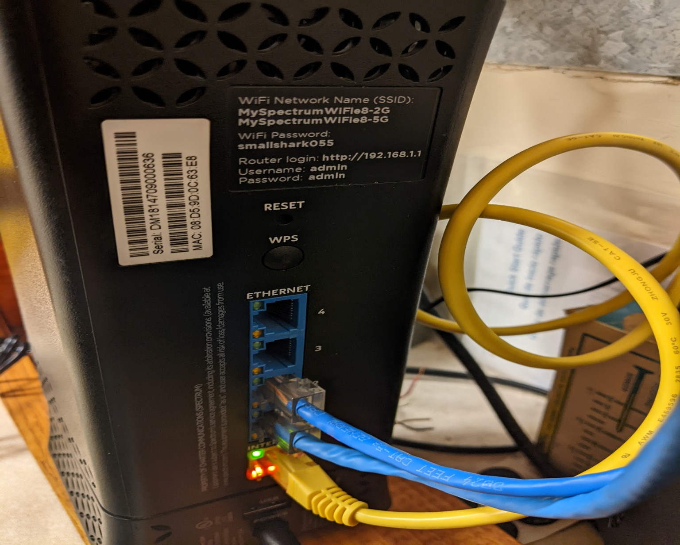

Above is a picture of the Spectrum Router connected to the modem

Internet port (yellow): connected to modem

Port 1: Unused ethernet cable (could not trace)

Port 2: Connected to Cisco switch

Upon testing both routers’ WAN connectivity, I found both routers were able to successfully connect to the WAN (separately). Both received the correct static IP configuration from the ISP. However, the NetGear Router was unable to support connection to the WAN without being connected to the Spectrum Router. LAN connections could be made, but no external internet connection could be supported. I believe there is a misconfiguration somewhere in either the Spectrum or NetGear Router that is causing this issue.

**Tasks:**

To confirm the Spectrum Router -> SG300-10PP ethernet cable is faulty, a different ethernet cable should be connected from the Spectrum Router to the 26-port Cisco switch. Two new ethernet cables should be run from the NetGear Router to the Cisco switches (SG200-26P, SG300-10PP). This is to provide a backup solution if one of the cables has issues in the future.

Remove the Spectrum Router from the LAN. Spectrum may have to be contacted if specific hardware requirements were saved to the Spectrum modem or business account for the Spectrum Router. Removing the Spectrum Router from the LAN would simplify the network topology, improve performance, reduce the possibility of hardware failure and simplify network management.

The image below is a basic network topology for the Kingdom Hall Network

